I changed the PDF handler back to preview so that it shows up in Chrome.

Change it so that Chrome uses the system print dialogue.

Create a custom paper size

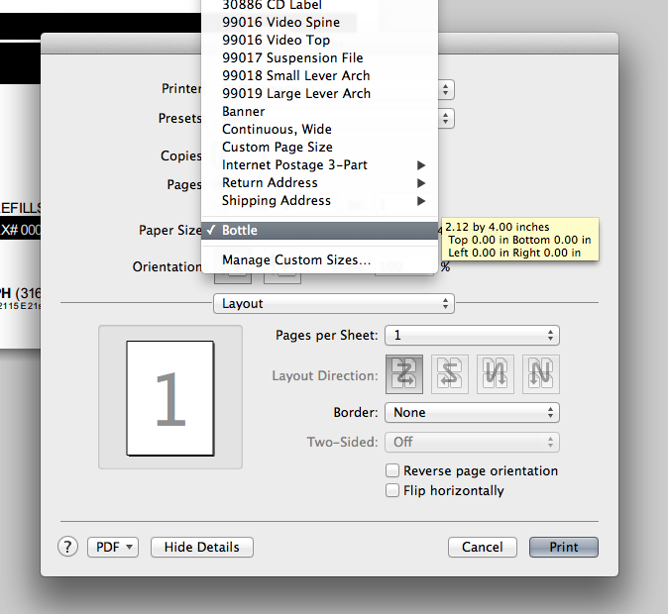

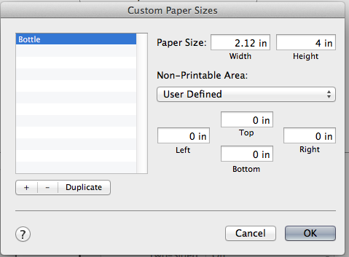

I then saved that as a preset

